Main Features :

* Booking System
* Flight Management
* Plane Maintenance
* Baggage Management
* Employee Management
* Official Sales Report

Ticket Booking System

|  |
| --- |
| CUSTOMER |
| ID ( PK ) |
| First Name |
| Last Name |
| Phone Number |
| Address |
| Username |
| Password |
| Gender |
| Passport Number |
| Number of Flights |
| Reward Points |
|  |
|  |

|  |
| --- |
| FLIGHT |
| Flight ID ( PK ) |
| Source |
| Destination |
| Arrival Time |
| Arrival Airport |
| Departure Time |
| Departure Airport |
| Price ID ( FK ) |
| Plane ID ( FK ) |
| Route ID ( FK ) |
|  |

|  |
| --- |
| FLIGHT HISTORY |
| Passenger ID ( PK ) |
| Flight Number ( FK ) |
| Plane ID ( FK ) |
|  |

|  |
| --- |
| ADMIN |
| Employee ID ( FK ) |
| Username |
| Password |

|  |
| --- |
| PRICING |
| Price ID ( PK ) |
| Business |
| Economy |
| Voucher |

Passenger Booking System:

* Book a flight
* Change booking info/ Manage bookings
* Flight Search
* Baggage info
* In Flight seating arrangements
* Pricing
* Sales office sales address
* Holiday package
* Boarding rules
* Special offer
* Terms and conditions

Employee Management:

|  |
| --- |
| EMPLOYEE |
| ID ( PK ) |
| First Name |
| Last Name |
| Phone Number |
| Address |
| Username |
| Password |
| Gender |
| Hire Date |
| Salary |
| Type |
| Nationality |
|  |

|  |
| --- |
| Staff |
| ID ( PK FK 4 ) |
| Title |
| Class |

|  |
| --- |
| Mechanic |
| ID ( PK FK 2 ) |
| Title |
| Certification |
|  |

|  |
| --- |
| PILOT |
| ID ( PK FK 1 ) |
| License Number |
| Med Type |
| Graduated from |
| Ratings/ Experience |

|  |
| --- |
| Accountant |
| ID ( PK FK 3 ) |
| Title |
| CPA Date |

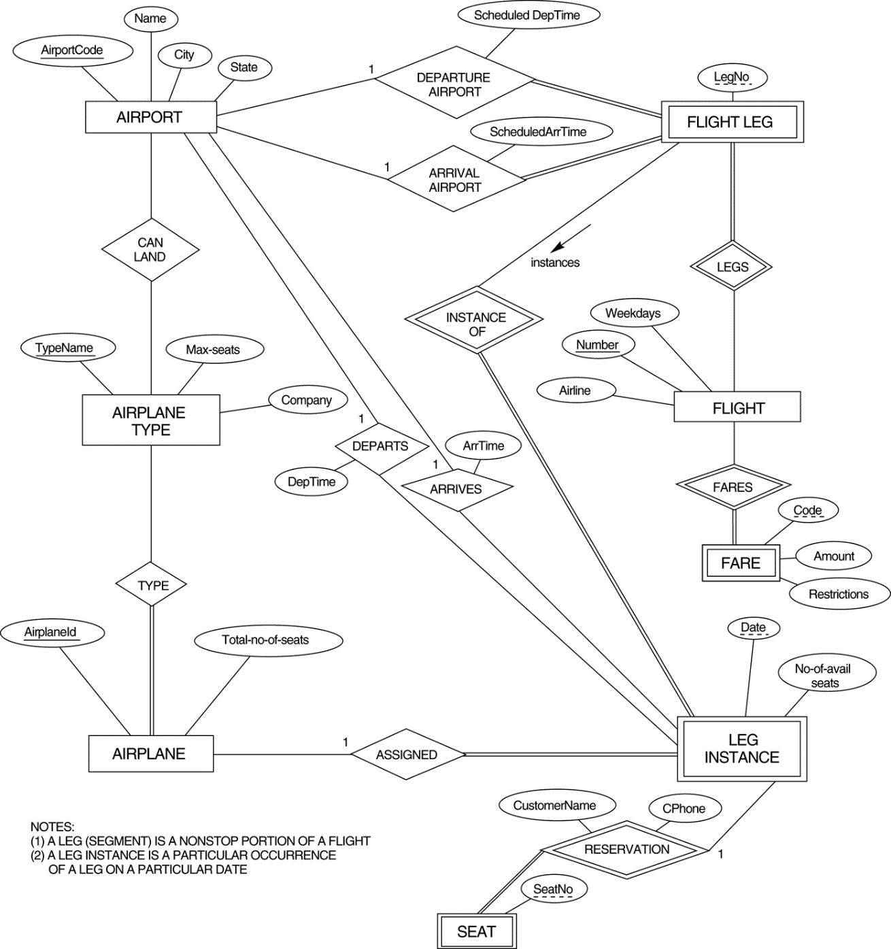

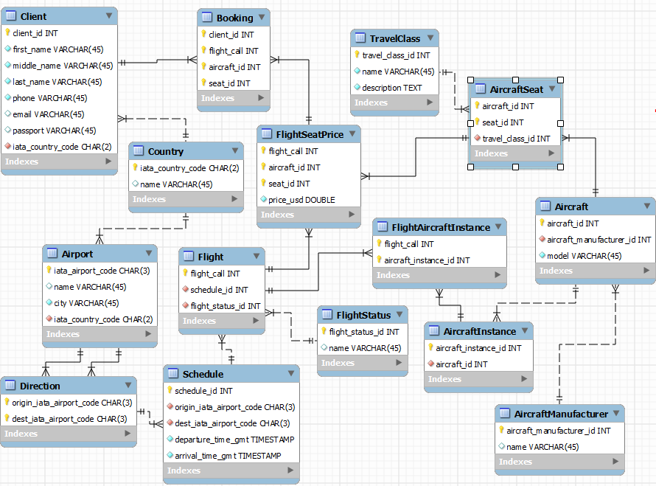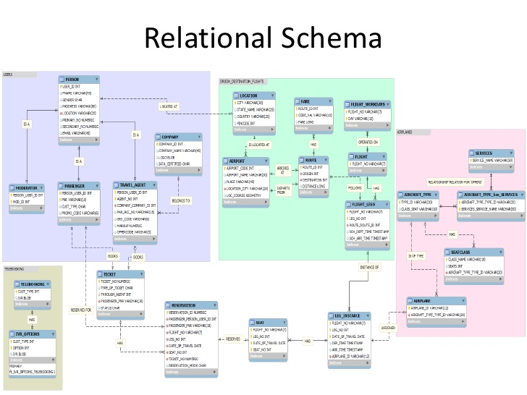

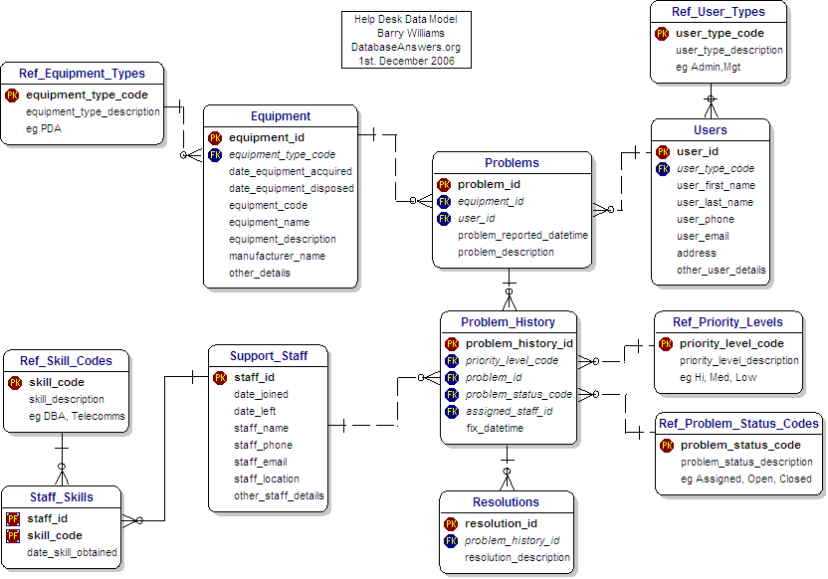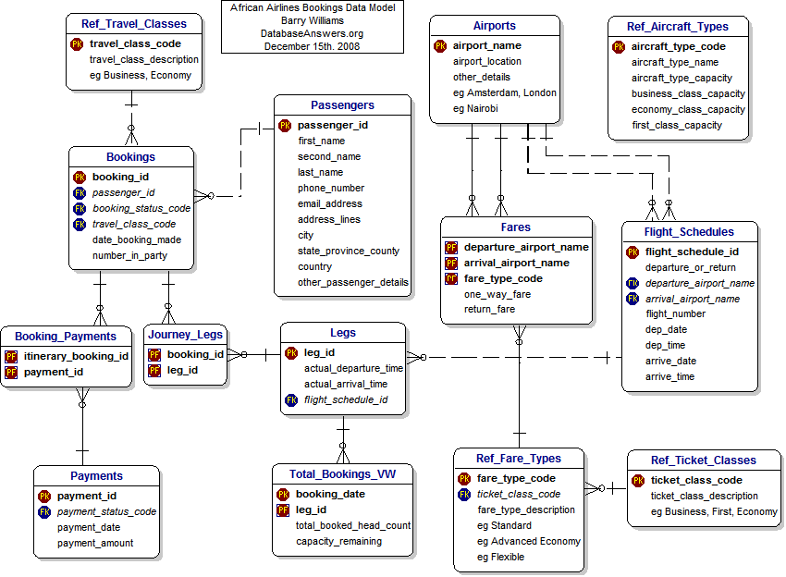

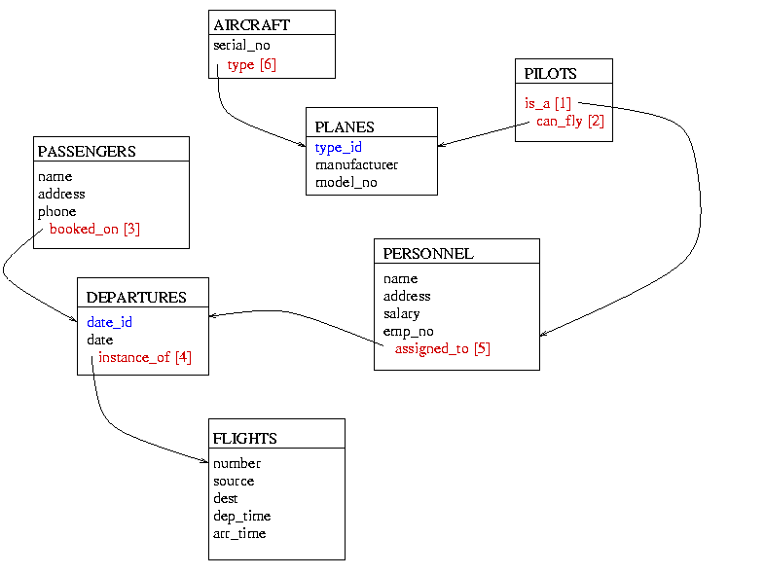

Flight Maintenance:

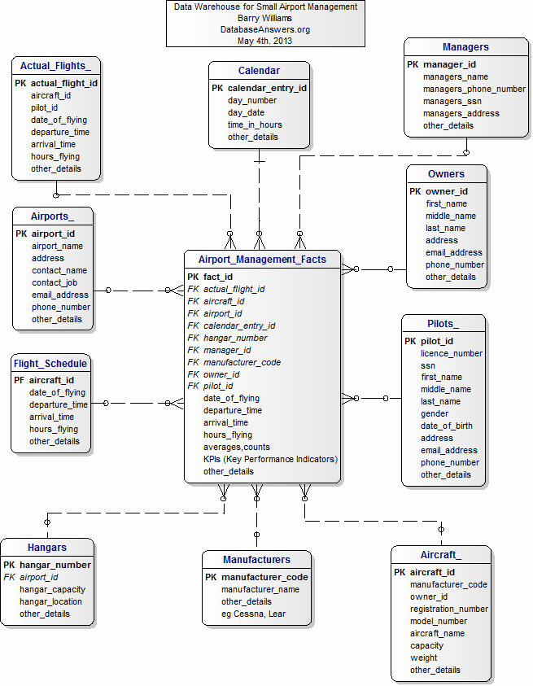

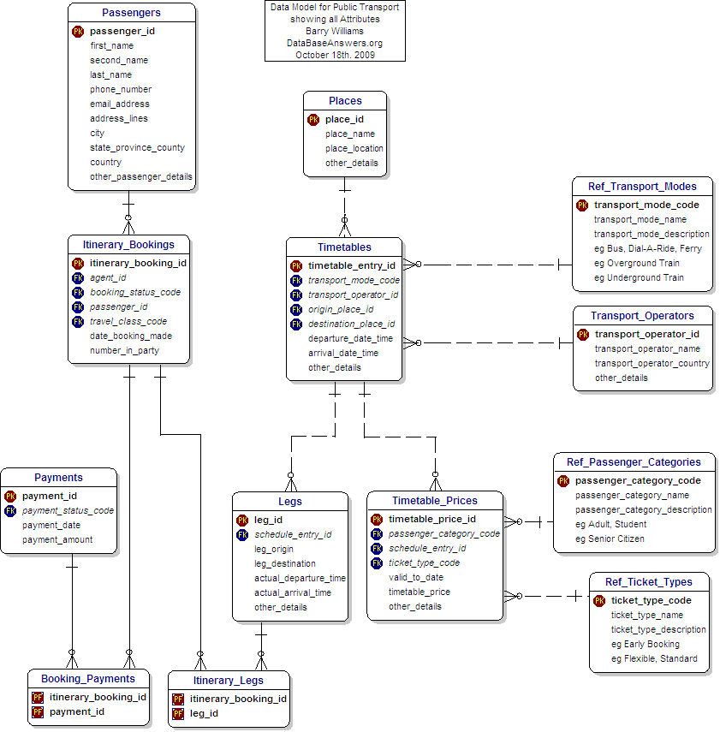

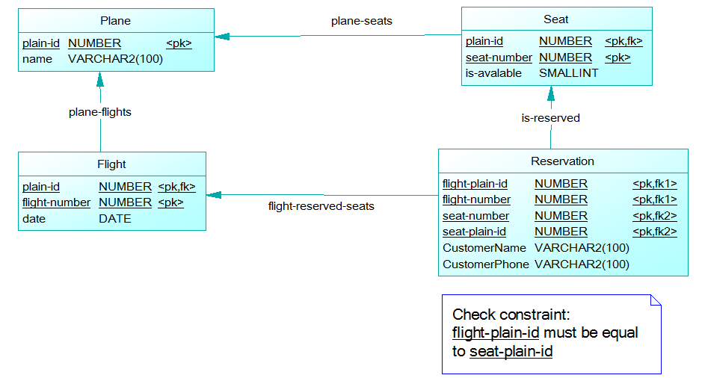

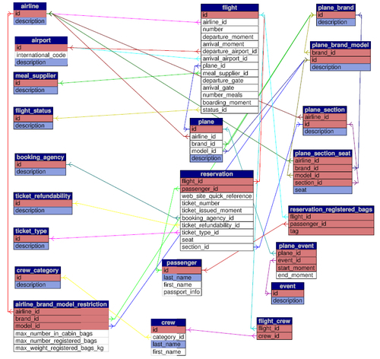

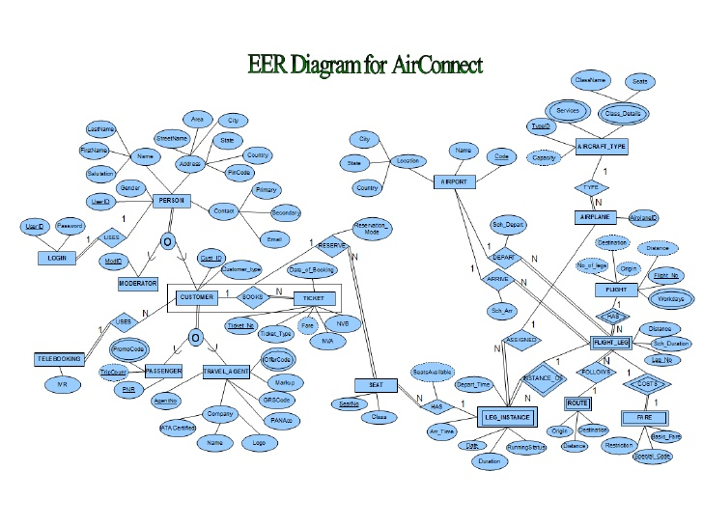

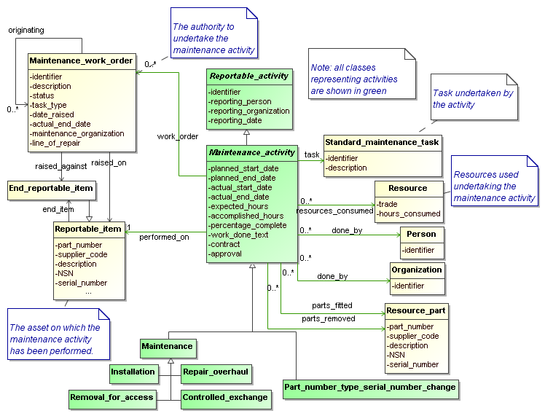

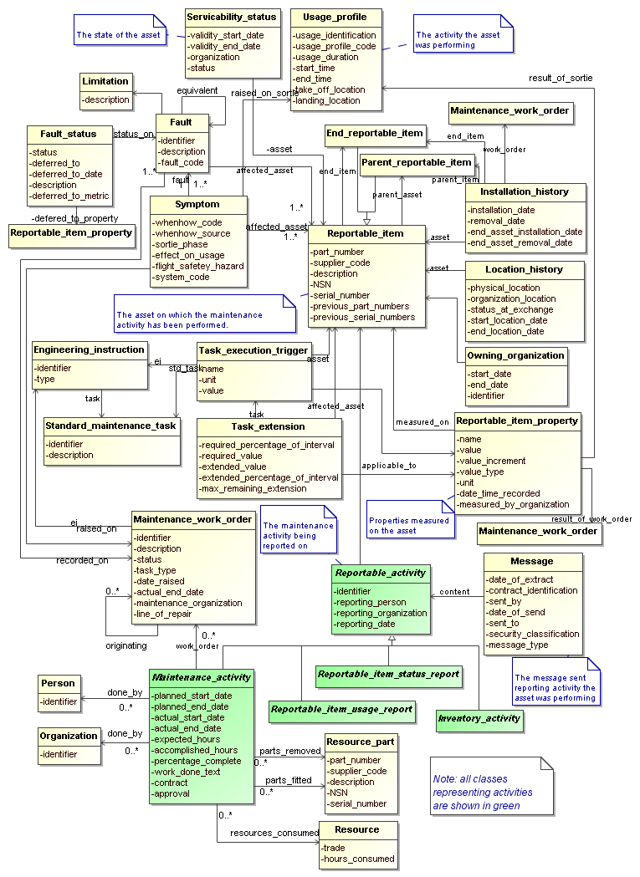

Baggage management Omitted.

Office sales report….

Commission discount, etc.